**Guided Capstone Project Report**

**Problem Statement:**

The goal of this project is to utilize a data-driven dynamic pricing strategy based on the importance of facilities relative to competitors in the market to achieve a 10% revenue increase for Big Mountain Resort in the upcoming ski season. By analyzing customer preferences, market trends, and competitor pricing, targeted adjustments can align with customer value perceptions and enhance revenue generation.

**Data Wrangling:**

During the data wrangling phase, the ski resort data was thoroughly cleaned and prepared for analysis. Missing values were handled by dropping rows with missing target ticket price data and addressing errors in specific feature values. The 'fastEight' and 'AdultWeekday' column was removed due to excessive missing values, and one resort with an incorrect skiable terrain area value was corrected. State-wide summary statistics were derived and merged with the ski data to provide additional context. The original ski resort data had 330 rows and after the cleaning process, it was reduced to 277 rows.

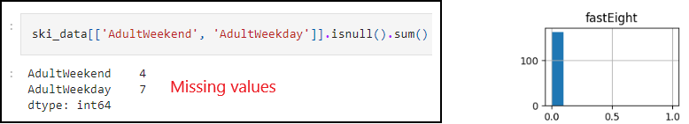

Fig.1 Missing data

**Exploratory Data Analysis:**

The EDA uncovered valuable insights into the relationships between ski resort features and ticket prices. Patterns emerged indicating the impact of features like vertical drop, fastQuads, and total chairs on ticket prices. State-level features also played a significant role in understanding the competitive landscape and influencing ticket prices.

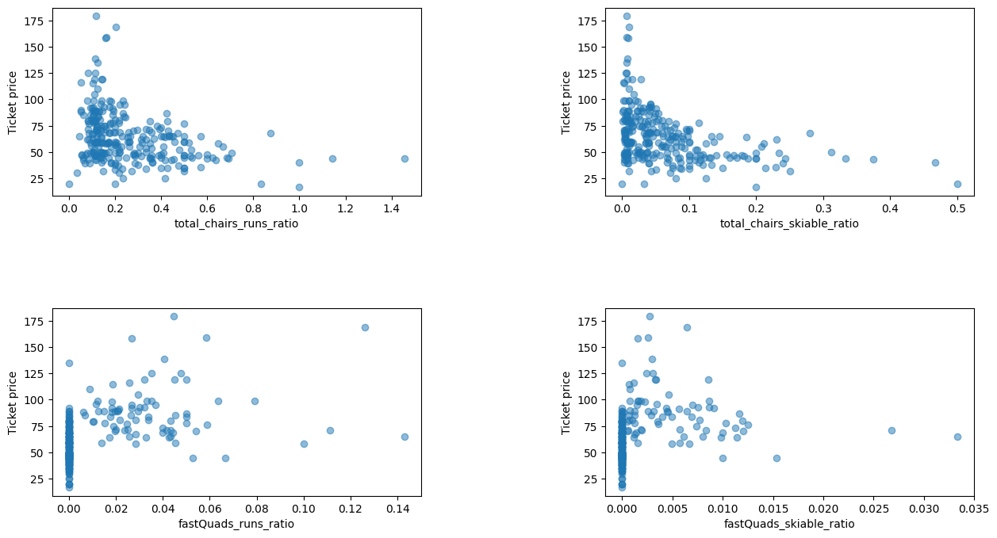

Fig. 2 Price Correlation

**Model Preprocessing and Training:**

Baseline and advanced models were built, including a linear regression model and a random forest regressor model. The random forest model showed better predictive performance for ticket prices and was chosen for further analysis. The model was saved with relevant details for future use.

**Modeling:**

The modeling phase involved building and evaluating predictive models to determine the key features influencing ticket prices for Big Mountain Resort. A linear regression model and a random forest regressor model were trained and validated using cross-validation. The random forest model, which demonstrated better predictive performance and consistency, was selected for further analysis. The model's metrics and performance were assessed to ensure its suitability for pricing recommendations and scenario modeling to optimize revenue generation for the resort.

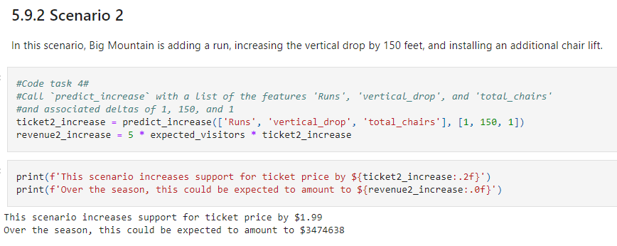

Fig.3 Adding a run, vertical drop and total chairs

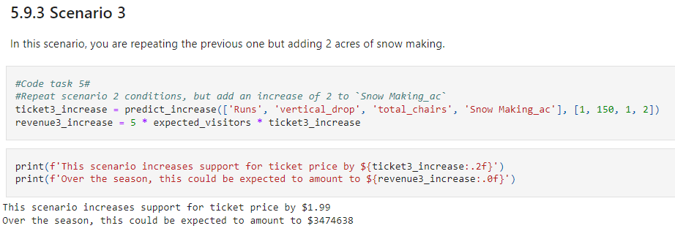

Fig.4 Adding a Snow making. Result = [ Makes no difference]

**Conclusion**:

The data-driven approach to pricing strategy and scenario modeling can help Big Mountain Resort maximize revenue while accurately reflecting the value of its facilities. By incorporating state and competitor data, the resort can make informed decisions to enhance customer experience and increase profitability.

**Future Scope of Work:**

Further work could involve obtaining detailed cost information, exploring competitor pricing strategies, and engaging with business executives to understand existing pricing strategies. The model can be integrated into decision support systems for scenario analysis and strategic planning, with training provided to key personnel for effective utilization.

Overall, the project provides valuable insights and recommendations for Big Mountain Resort to optimize pricing strategies and drive revenue growth in the upcoming ski season.